Use Cases Description
UC5- Group Borrower Management

For

Meeting Room
Booking System
(MRBS)

Prepared by K15T1-Team11
Van Lang University
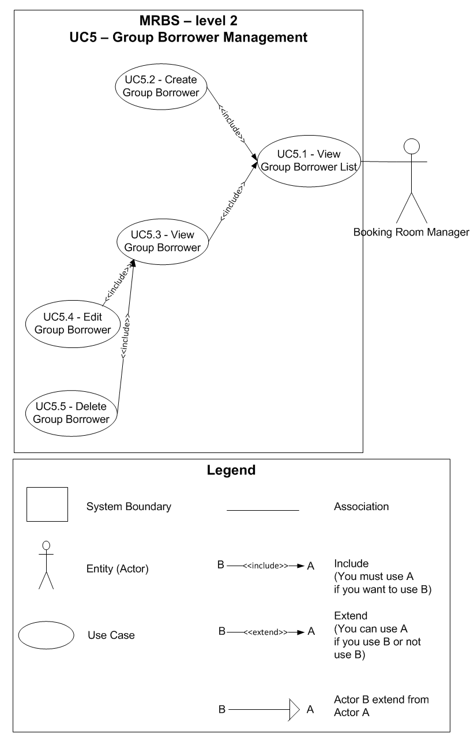
Table of Contents
UC5.1 – View Group Borrower List 3
UC5.2 – Create Group Borrower 4
UC5.3 – View Group Borrower 4
UC5.4 – Edit Group Borrower 5
UC5.5 – Delete Group Borrower 6

UC5.1 – View Group Borrower List
ID | UC5.1
Name | View Group Borrower List
Author | Tin Nguyen | Modify by | Tam Do
Date | 06/201/12 | Update | 06/29/12
Actor | Booking Room Manager
Description | User can view a list of group borrower
Precondition | User signed in system by Booking Room Manager’s account
Post condition: | System shows all group borrower
Main flow: | 1. User press “Danh mục”  2. User choose “Quản lý nhóm người mượn”  3. System show new dialog “Quản lý nhóm người mượn”  4. System show a list of group borrower
Alternative flow:
Exception :
Includes:
Priority: | Normal
Business rules:
Mockup screen

UC5.2 – Create Group Borrower
ID | UC5.2
Name | Create Group Borrower
Author | Tin Nguyen | Modify by | Tam Do
Date | 06/20/12 | Update | 07/09/12
Actor | Booking Room Manager
Description | User can create a new group borrower
Precondition | User signed in system by Booking Room Manager’s account  User staying at “Quản lý nhóm người mượn” form
Post condition: | System create a new group borrower in database
Main flow: | 1. User press “Thêm mới” button  2. System change form to create a new group borrower  3. System create a code for new group borrower and fill in “Mã nhóm” field  4. User fill in the form  5. User press “Lưu” button  6. System check the valid of information (BR5.2.01, BR5.2.02)  7. System save a new group borrower in database  8. System show message that “Thêm nhóm người mượn thành công” with “OK” button
Alternative flow: | After step 4 of main flow:  5. User press “Hủy” button  6. System change form to not create a new group borrower
Alternative flow: | After step 6 of main flow (BR5.2.01):  7. System show message that “Các thông tin có (*) không được để trống” with “OK” button
Alternative flow: | After step 6 of main flow (BR5.2.02):  7. System show message that “Thông tin nhập vào không hợp lệ” with “OK” button
Exception :
Includes:
Priority: | Normal
Business rules: | BR5.2.01 – Required field not accept null: “Mã nhóm”; “Tên nhóm”  BR5.2.02 – “Tên nhóm” accept alphanumeric and can use Vietnamese language
Mockup screen

UC5.3 – View Group Borrower
ID | UC5.3
Name | View Group Borrower
Author | Tin Nguyen | Modify by | Tam Do
Date | 06/20/12 | Update | 06/29/12
Actor | Booking Room Manager
Description | User can view a detail group borrower information
Precondition | User signed in system by Booking Room Manager’s account  User staying at “Quản lý nhóm người mượn” form
Post condition: | System show a detail group borrower information that user choose
Main flow: | 1. User choose a group borrower from list of room  2. System show a detail group borrower information that user choose
Alternative flow:
Exception :
Includes:
Priority: | Normal
Business rules:
Mockup screen

UC5.4 – Edit Group Borrower
ID | UC5.4
Name | Edit Room
Author | Tin Nguyen | Modify by | Tam Do
Date | 06/20/12 | Update | 07/12/12
Actor | Booking Room Manager
Description | User can edit a group borrower information
Precondition | User signed in system by Booking Room Manager’s account  User staying at “Quản lý nhóm người mượn” form and viewing a detail group borrower information
Post condition: | System edit a group borrower information in database
Main flow: | 1. User edit a group borrower information that accept to edit  2. User press “Lưu” button  3. System check the valid of information (BR5.4.01,BR5.4.02)  4. System save a room information that edited in database  5. System show message that “Chỉnh sửa thông tin thành công” with “OK” button
Alternative flow: | After step 1 of main flow:  2. User press “Hủy” button  3. System change form to not create a new group borrower
Alternative flow: | After step 3 of main flow (BR5.4.01):  4. System show message that “Các thông tin có (*) không được để trống” with “OK” button
Alternative flow: | After step 3 of main flow (BR5.4.02):  4. System show message that “Thông tin nhập vào không hợp lệ” with “OK” button
Exception :
Includes:
Priority: | Normal
Business rules: | BR5.4.01 – Required field not accept null: “Mã nhóm”; “Tên nhóm”  BR5.4.02 – “Tên nhóm” accept alphanumeric only, can use Vietnamese language
Mockup screen

UC5.5 – Delete Group Borrower
ID | UC5.5
Name | Delete Group Borrower
Author | Tin Nguyen | Modify by | Tam Do
Date | 06/20/12 | Update | 07/12/12
Actor | Booking Room Manager
Description | User can delete a group borrower information
Precondition | User signed in system by Booking Room Manager’s account  User staying at “Quản lý nhóm người mượn” form and viewing a detail group borrower information
Post condition: | System delete a group borrower information in database
Main flow: | 1. User press “Xóa” button  2. System show message that “Bạn có muốn xóa thông tin này khỏi hệ thống không?” with “Yes” and “No” button  3. User press “Yes” button  4. System delete a group borrower information in database
Alternative flow: | After step 2 of main flow:  3. User press “No” button  4. Nothing appears
Exception :
Includes:
Priority: | Normal
Business rules:
Mockup screen

